Sales Management System using MySQL

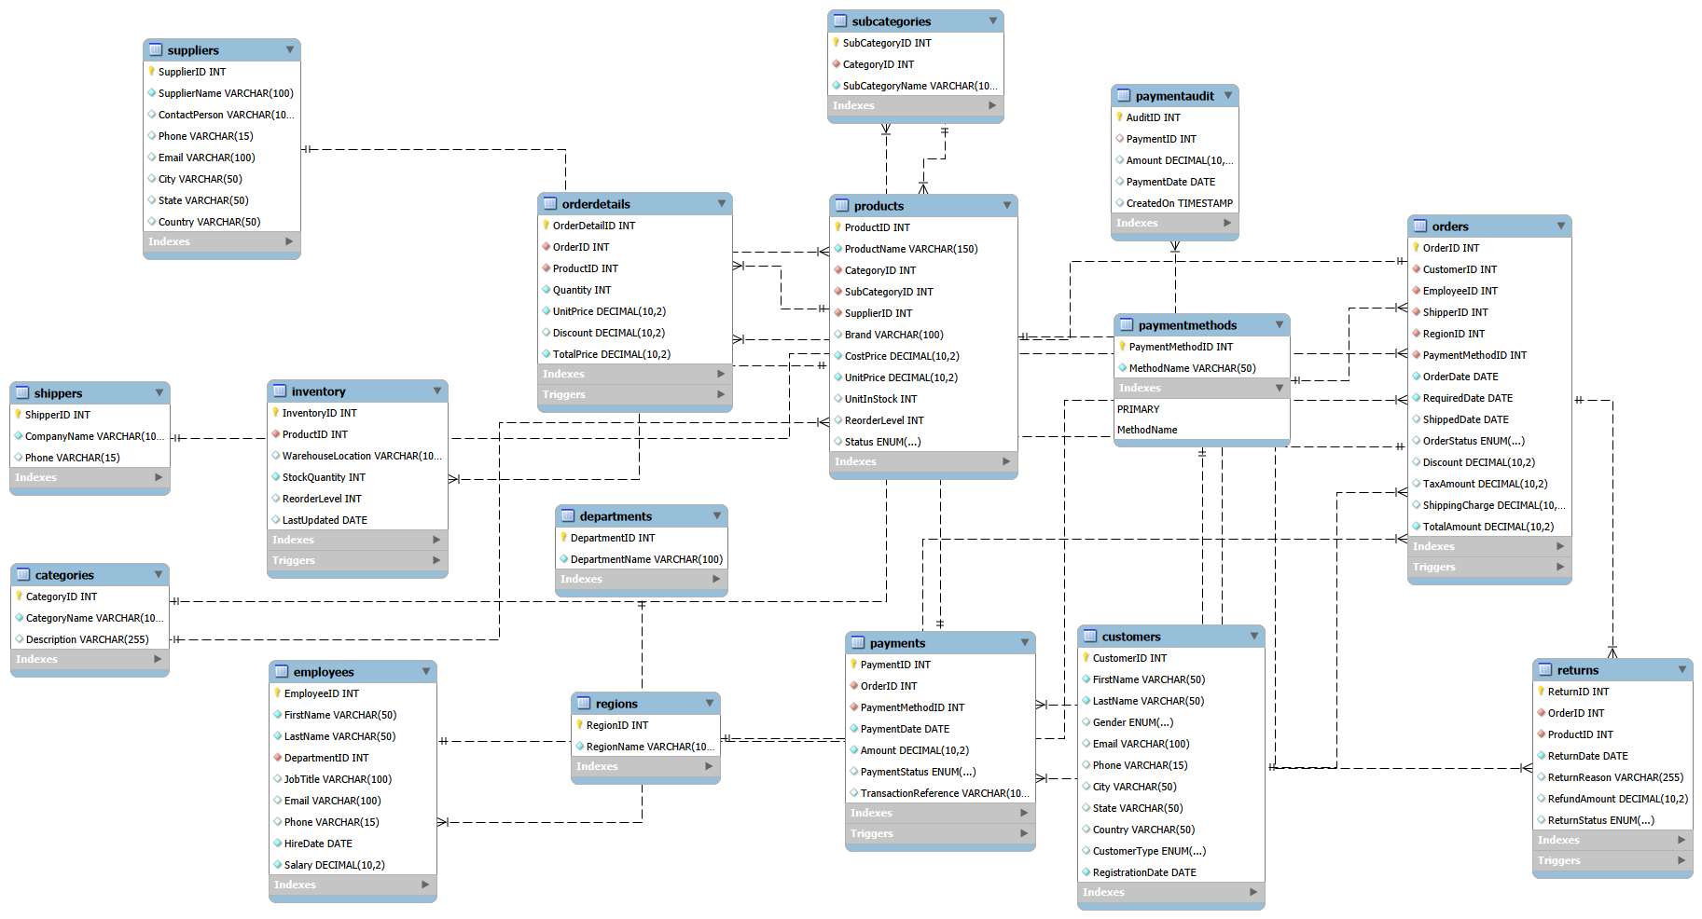
Table Schema

PROJECT OBJECTIVE :
The objective of this project is to develop a Sales Management System using MySQL to efficiently manage customers, products, orders, payments, returns, and inventory. The project demonstrates database design, SQL queries, stored procedures, and triggers to ensure accurate data management and improve sales operations.

BASIC LEVEL QUESTIONS :
Q1. Retrieve all customer records.
SELECT * FROM Customers;

Q2. Display customer first name, last name, and city.
SELECT FirstName, LastName, City
FROM Customers;

Q3. Display all active products.
SELECT *
FROM Products
WHERE Status = 'Active';

Q4. Display customers from Chennai.
SELECT *
FROM Customers
WHERE City = 'Chennai';

Q5. Display products with a unit price greater than 1000.
SELECT *
FROM Products
WHERE UnitPrice > 1000;

Q6. Display employees whose salary is greater than 50,000.
SELECT *
FROM Employees
WHERE Salary > 50000;

Q7. Display all delivered orders.
SELECT *
FROM Orders
WHERE OrderStatus = 'Delivered';

Q8. Display products that are below the reorder level.
SELECT *
FROM Inventory
WHERE StockQuantity < ReorderLevel;

Q9. Display all premium customers.
SELECT *
FROM Customers
WHERE CustomerType = 'Premium';

Q10. Display the top 10 most expensive products.
SELECT *
FROM Products
ORDER BY UnitPrice DESC
LIMIT 10;

Q11. Count the total number of customers.
SELECT COUNT(*) AS TotalCustomers
FROM Customers;

Q12. Find the average salary of employees.
SELECT AVG(Salary) AS AverageSalary
FROM Employees;

Q13. Find the highest product price.
SELECT MAX(UnitPrice) AS HighestPrice
FROM Products;

Q14. Find the lowest product cost price.
SELECT MIN(CostPrice) AS LowestCostPrice
FROM Products;

Q15. Calculate the total stock available in inventory.
SELECT SUM(StockQuantity) AS TotalStock
FROM Inventory;

Q16. Display customers ordered by latest registration date.
SELECT *
FROM Customers
ORDER BY RegistrationDate DESC;

Q17. Display products whose names start with 'S'.
SELECT *
FROM Products
WHERE ProductName LIKE 'S%';

Q18. Display Samsung products.
SELECT *
FROM Products
WHERE Brand = 'Samsung';

Q19. Display completed returns.
SELECT *
FROM Returns
WHERE ReturnStatus = 'Completed';

Q20. Display orders placed during the year 2025.
SELECT *
FROM Orders
WHERE OrderDate BETWEEN '2025-01-01' AND '2025-12-31';

INTERMEDIATE LEVEL QUESTIONS :
Q21. Display customer names along with their order details.
SELECT o.OrderID,
c.FirstName,
c.LastName,
o.OrderDate
FROM Orders o
JOIN Customers c
ON o.CustomerID = c.CustomerID;

Q22. Display product name with its category and supplier.
SELECT p.ProductName,
c.CategoryName,
s.SupplierName
FROM Products p
JOIN Categories c
ON p.CategoryID = c.CategoryID
JOIN Suppliers s
ON p.SupplierID = s.SupplierID;

Q23. Display employee names with their department.
SELECT CONCAT(e.FirstName,' ',e.LastName) AS EmployeeName,
d.DepartmentName
FROM Employees e
JOIN Departments d
ON e.DepartmentID = d.DepartmentID;

Q24. Display the total number of orders placed by each customer.
SELECT c.CustomerID,
c.FirstName,
COUNT(o.OrderID) AS TotalOrders
FROM Customers c
LEFT JOIN Orders o
ON c.CustomerID = o.CustomerID
GROUP BY c.CustomerID, c.FirstName;

Q25. Calculate the total sales made by each customer.
SELECT c.CustomerID,
c.FirstName,
SUM(o.TotalAmount) AS TotalSales
FROM Customers c
JOIN Orders o
ON c.CustomerID = o.CustomerID
GROUP BY c.CustomerID, c.FirstName;

Q26. Display the total quantity sold for each product.
SELECT p.ProductName,
SUM(od.Quantity) AS TotalQuantitySold
FROM OrderDetails od
JOIN Products p
ON od.ProductID = p.ProductID
GROUP BY p.ProductName;

Q27. Display the top 10 best-selling products.
SELECT p.ProductName,
SUM(od.Quantity) AS TotalSold
FROM OrderDetails od
JOIN Products p
ON od.ProductID = p.ProductID
GROUP BY p.ProductName
ORDER BY TotalSold DESC
LIMIT 10;

Q28. Display customers who have placed more than 5 orders.
SELECT c.CustomerID,
c.FirstName,
COUNT(o.OrderID) AS OrdersCount
FROM Customers c
JOIN Orders o
ON c.CustomerID = o.CustomerID
GROUP BY c.CustomerID, c.FirstName
HAVING COUNT(o.OrderID) > 5;

Q29. Calculate the total revenue generated through each payment method.
SELECT pm.MethodName,
SUM(p.Amount) AS TotalRevenue
FROM Payments p
JOIN PaymentMethods pm
ON p.PaymentMethodID = pm.PaymentMethodID
GROUP BY pm.MethodName;

Q30. Find the average order amount in each region.
SELECT r.RegionName,
AVG(o.TotalAmount) AS AverageOrderAmount
FROM Orders o
JOIN Regions r
ON o.RegionID = r.RegionID
GROUP BY r.RegionName;

Q31. Display products that have never been ordered.
SELECT ProductName
FROM Products
WHERE ProductID NOT IN
(
SELECT ProductID
FROM OrderDetails
);

Q32. Display customers who have never placed an order.
SELECT CustomerID,
FirstName
FROM Customers
WHERE CustomerID NOT IN
(
SELECT CustomerID
FROM Orders
);

Q33. Display the latest order date for each customer.
SELECT CustomerID,
MAX(OrderDate) AS LatestOrder
FROM Orders
GROUP BY CustomerID;

Q34. Display the employee who handled the highest number of orders.
SELECT e.EmployeeID,
e.FirstName,
COUNT(o.OrderID) AS TotalOrders
FROM Employees e
JOIN Orders o
ON e.EmployeeID = o.EmployeeID
GROUP BY e.EmployeeID, e.FirstName
ORDER BY TotalOrders DESC
LIMIT 1;

Q35. Display monthly sales summary.
SELECT YEAR(OrderDate) AS Year,
MONTH(OrderDate) AS Month,
SUM(TotalAmount) AS MonthlySales
FROM Orders
GROUP BY YEAR(OrderDate), MONTH(OrderDate)
ORDER BY Year, Month;

Q36. Display the top 5 customers based on total purchase amount.
SELECT c.CustomerID,
c.FirstName,
SUM(o.TotalAmount) AS TotalPurchase
FROM Customers c
JOIN Orders o
ON c.CustomerID = o.CustomerID
GROUP BY c.CustomerID, c.FirstName
ORDER BY TotalPurchase DESC
LIMIT 5;

Q37. Count the number of products available in each category.
SELECT c.CategoryName,
COUNT(p.ProductID) AS TotalProducts
FROM Categories c
JOIN Products p
ON c.CategoryID = p.CategoryID
GROUP BY c.CategoryName;

Q38. Display orders containing more than three products.
SELECT OrderID,
COUNT(ProductID) AS ProductCount
FROM OrderDetails
GROUP BY OrderID
HAVING COUNT(ProductID) > 3;

Q39. Display the total refund amount based on return status.
SELECT ReturnStatus,
SUM(RefundAmount) AS TotalRefund
FROM Returns
GROUP BY ReturnStatus;

Q40. Rank products based on total sales amount.
SELECT p.ProductName,
SUM(od.TotalPrice) AS SalesAmount,
RANK() OVER(ORDER BY SUM(od.TotalPrice) DESC) AS ProductRank
FROM OrderDetails od
JOIN Products p
ON od.ProductID = p.ProductID
GROUP BY p.ProductName;

ADVANCED LEVEL QUESTIONS :
Q41. Create a stored procedure to retrieve all orders of a specific customer.
DELIMITER //

CREATE PROCEDURE GetCustomerOrders(IN p_CustomerID INT)
BEGIN
SELECT *
FROM Orders
WHERE CustomerID = p_CustomerID;
END //

DELIMITER ;

Q42. Create a stored procedure to retrieve products by category.
DELIMITER //

CREATE PROCEDURE GetProductsByCategory(IN p_CategoryID INT)
BEGIN
SELECT *
FROM Products
WHERE CategoryID = p_CategoryID;
END //

DELIMITER ;

Q43. Create a stored procedure to calculate the total sales of a customer.
DELIMITER //

CREATE PROCEDURE GetCustomerSales(IN p_CustomerID INT)
BEGIN
SELECT SUM(TotalAmount) AS TotalSales
FROM Orders
WHERE CustomerID = p_CustomerID;
END //

DELIMITER ;

Q44. Create a stored procedure to retrieve orders between two dates.
DELIMITER //

CREATE PROCEDURE GetOrdersBetweenDates
(
IN StartDate DATE,
IN EndDate DATE
)
BEGIN
SELECT *
FROM Orders
WHERE OrderDate BETWEEN StartDate AND EndDate;
END //

DELIMITER ;

Q45. Create a stored procedure to display products with low stock.
DELIMITER //

CREATE PROCEDURE GetLowStockProducts()
BEGIN
SELECT *
FROM Inventory
WHERE StockQuantity < ReorderLevel;
END //

DELIMITER ;

Q46. Create a trigger to automatically reduce inventory stock after a new order is placed.
DELIMITER //

CREATE TRIGGER trg_UpdateInventory
AFTER INSERT
ON OrderDetails
FOR EACH ROW
BEGIN
UPDATE Inventory
SET StockQuantity = StockQuantity - NEW.Quantity
WHERE ProductID = NEW.ProductID;
END //

DELIMITER ;

Q47. Create a trigger to automatically increase inventory stock when a product is returned.
DELIMITER //

CREATE TRIGGER trg_ReturnInventory
AFTER INSERT
ON Returns
FOR EACH ROW
BEGIN
UPDATE Inventory
SET StockQuantity = StockQuantity + 1
WHERE ProductID = NEW.ProductID;
END //

DELIMITER ;

Q48. Create a trigger to prevent orders with a negative total amount.
DELIMITER //

CREATE TRIGGER trg_CheckTotalAmount
BEFORE INSERT
ON Orders
FOR EACH ROW
BEGIN
IF NEW.TotalAmount < 0 THEN
SIGNAL SQLSTATE '45000'
SET MESSAGE_TEXT = 'Total Amount cannot be negative';
END IF;
END //

DELIMITER ;

Q49. Create a trigger to automatically update the LastUpdated field in the Inventory table.
DELIMITER //

CREATE TRIGGER trg_LastUpdated
BEFORE UPDATE
ON Inventory
FOR EACH ROW
BEGIN
SET NEW.LastUpdated = CURDATE();
END //

DELIMITER ;

Q50. Create a PaymentAudit table and a trigger to store payment transaction history.
CREATE TABLE PaymentAudit
(
AuditID INT AUTO_INCREMENT PRIMARY KEY,
PaymentID INT,
Amount DECIMAL(10,2),
PaymentDate DATE,
CreatedOn TIMESTAMP DEFAULT CURRENT_TIMESTAMP
);

DELIMITER //

CREATE TRIGGER trg_PaymentAudit
AFTER INSERT
ON Payments
FOR EACH ROW
BEGIN
INSERT INTO PaymentAudit
(
PaymentID,
Amount,
PaymentDate
)
VALUES
(
NEW.PaymentID,
NEW.Amount,
NEW.PaymentDate
);
END //

DELIMITER ;

